**What is 5G NSA network architecture?**

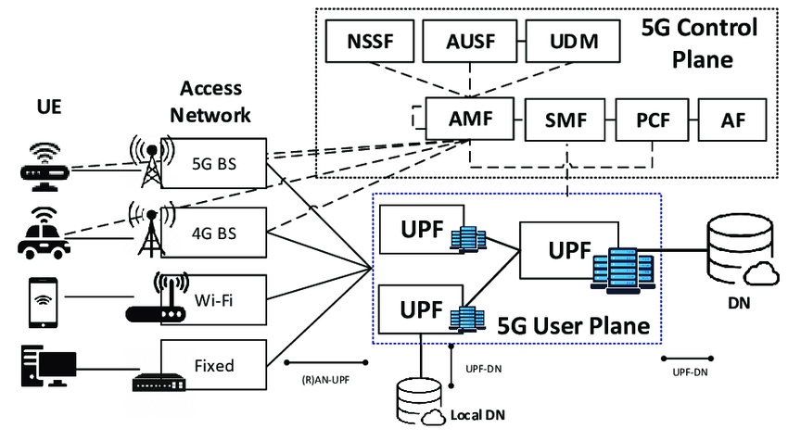

**Fig: 5G NSA network architecture.**

5G NSA (Non-Standalone) network architecture refers to an initial deployment approach for 5G networks that relies on existing 4G LTE infrastructure to support certain aspects of the 5G technology. Here’s a breakdown of the key components and how they work together:

1. **LTE (4G) Network**: The foundation of 5G NSA architecture is the existing LTE network, which continues to handle the control signaling and certain data functions.
2. **5G NR (New Radio)**: This is the new radio interface that operates in higher frequency bands and enables faster data rates and lower latency compared to LTE.
3. **gNB (5G New Radio Base Station)**: The gNB is the base station that transmits and receives the 5G NR signals. It works alongside existing LTE eNodeBs (base stations).
4. **eNodeB (LTE Base Station)**: This is the LTE base station that remains part of the network in 5G NSA architecture. It handles LTE signaling and data sessions.
5. **NGC (Next Generation Core)**: The 5G NSA architecture connects to the existing LTE Evolved Packet Core (EPC) for certain functions, such as mobility management and bearer control.
6. **Control Plane Separation**: In NSA architecture, the control plane for both LTE and 5G NR is handled by the LTE EPC. This means signaling messages for setting up connections and managing sessions go through the LTE core network.
7. **Data Plane Integration**: Data traffic can be split between LTE and 5G NR depending on the capabilities and requirements. Data sessions can be anchored in LTE or 5G NR, with LTE typically handling most of the user data initially.
8. **Dual Connectivity**: Devices in 5G NSA architecture can simultaneously connect to LTE and 5G NR networks using a feature called Dual Connectivity. This allows for improved data rates and continuity of service as 5G coverage expands.
9. **Transition to Standalone (SA) 5G**: While 5G NSA allows for quicker deployment using existing infrastructure, the long-term goal is to transition to Standalone (SA) 5G architecture. SA 5G does not rely on LTE infrastructure and is fully independent, utilizing a new 5G core network (5GC) for all control and user plane functions.

Overall, 5G NSA architecture leverages the strengths of existing LTE networks while introducing the capabilities of 5G NR, paving the way for faster speeds, lower latency, and new applications without requiring an immediate overhaul of the entire network infrastructure.